COVID SAFETY GUIDANCE

REDUCING DEPENDENCE, PROMOTING INDEPENDENCE

126 STATION STREET • BURTON UPON TRENT • STAFFORDSHIRE • DE14 1BX
CHOOSE THE RIGHT ROAD TO RECOVERY
T 01283 537280

www.bacandoconnor.co.uk

BAC O’CONNOR COVID SAFETY GUIDANCE

In response to the COVID-19 (Coronavirus) outbreak BAC O’Connor Centre has been strictly adhering to all Government and regulatory guidance and taking all possible precautions to ensure the safety of our clients and staff since the start of the pandemic and will continue to do so.

Clients can be assured that they will still be getting the highest quality treatment and support we can offer. We have rigorous risk assessments and measures in place to ensure that clients and staff are supported through this challenging time.

We have clear pre-admission and admission processes in place to minimise risk.

We have additional measure in place for all admissions including temperature checks and additional screening with our clinical team.

Staff are extra vigilant with hand washing and additional cleaning has been in place across all the buildings since the outbreak started.

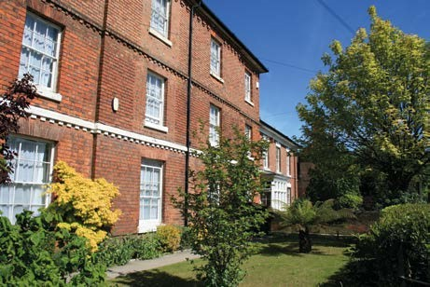
All external groups were cancelled from the start of the outbreak on March 16, 2020 to minimise infection risk within the centre. Clients in the community are being supported through regular telephone contact with our team of therapists and we are utilising technology fully to provide virtual groups and support.

Specific Measures in place for clients:
- Prior to admission clients are required to complete a questionnaire, which assesses their individual Covid risk, which is based on vaccination status, health and vulnerabilities to Covid plus household information.

- Temperature checks are taken on admission and daily throughout your stay.

- Where isolation is required this will be facilitated to ensure you are comfortable and have access to virtual groups and one to one support.

- Isolation may not be required on admission subject to certain criteria including being fully vaccinated and providing a negative PCR test 72 hours prior to admission. Our Assessment team will advise you of any isolation period required prior to your admission.

- PCR testing is every 28 days and lateral flow are carried out testing should there be any concerns.

- All staff are testing regularly in line with Government guidance.

- In the event that there is an outbreak of Coronavirus during your stay with us, you will be required to isolate but we will ensure that you are fully supported by our experienced staff teams and all clients and staff have enhanced testing.

